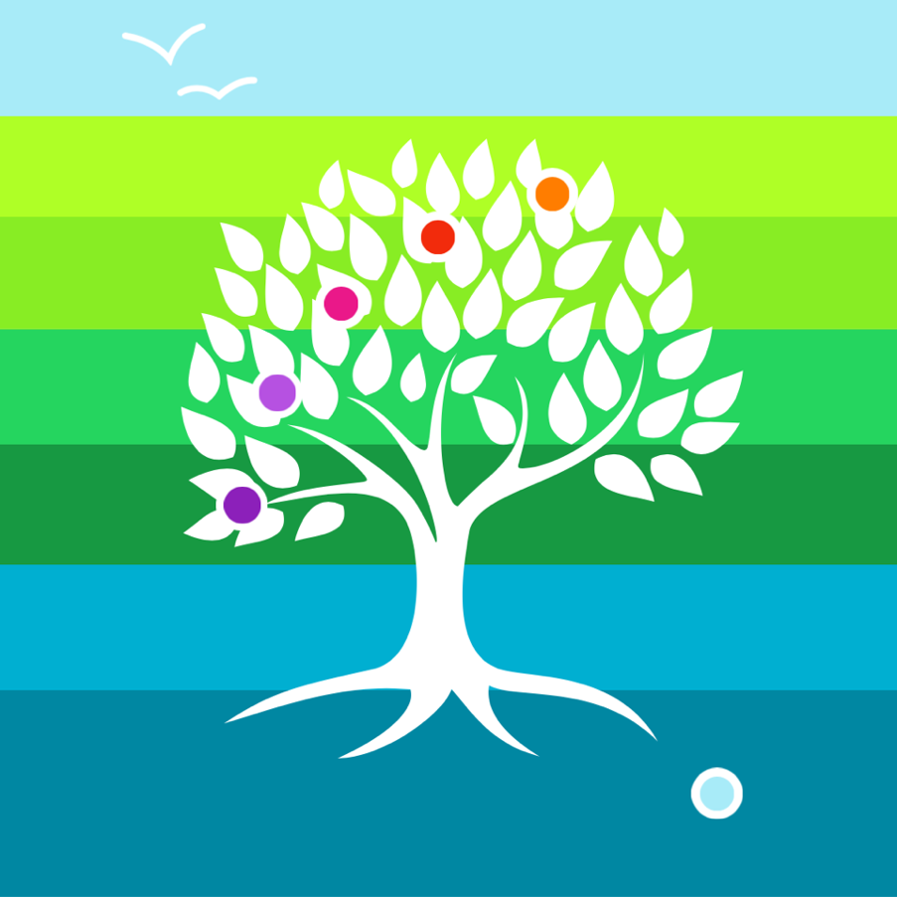

The Wildings Lovaton
Accessibility Policy & Accessibility Plan

The term “school” is used throughout. The nature of school as defined by The Wildings is made clear in the published Visions, Aims, Values and Standards Documentation and website information. This will also be reflected consistently and coherently in The Wildings constitution as a Community Interest Company (CIC) as detailed in “Office of the Regulator of Community Interest Companies: Information and guidance notes – Chapter 5: constitutional documents”.
The terms “principal”, “governance” and “governance lead” are used throughout. The nature of leadership and governance for a Community Interest Company is detailed within the “Office of the Regulator of Community Interest Companies: Information and guidance notes – Chapter 9: corporate governance”.
The term “reporting” is used throughout. It is made clear in the policies whether reporting is internal or external, compliance or quality assurance. Reporting obligations arising from being a CIC are detailed in “Office of the Regulator of Community Interest Companies: Information and guidance notes – Chapter 8: statutory obligations”.

Contents:
Statement of intent
- Legal framework
- Definition
- Roles and responsibilities
- Accessibility Plan
- Equal opportunities
- Admissions
- Curriculum
- Physical environment
- Monitoring and review
Appendices
- Accessibility Plan Template

Statement of intent
The Wildings is committed to taking all steps to avoid placing anyone at a substantial disadvantage and works closely with young people with disabilities, their families and any relevant outside agencies in order to remove any potential barriers to their learning experience.
The school is active in promoting an inclusive positive environment by ensuring that every young person is given equal opportunity to develop socially, to learn and to enjoy school life. The school continually looks for ways to improve accessibility within the school through data collection, parent questionnaires and discussions.
We believe that a greater level of wellbeing from young people and colleagues can be achieved by realising and celebrating the uniqueness of individuals. The Wildings is committed to creating a prejudice-free environment where individuals feel confident and at ease. This environment will be achieved by:
- Communicating non-violently.
- Always treating all members of the school community fairly.
- Developing an understanding of diversity and the benefits it can have.
- Adopting an inclusive attitude.
- Adopting an inclusive curriculum that is accessible to all.
- Encouraging compassion and open-mindedness.
- Equipping our community to understand why prejudice and discrimination happen and the impacts they have on people.
- Using democracy within the school as a platform to discuss and resolve real life incidents of discrimination.
We are committed to having a balanced and fair curriculum. We believe that our young people should be exposed to ideas and concepts that may challenge their understanding, to help young people learn about and become more accepting and inclusive of others. Challenging and controversial concepts will be delivered in a way that prevents discrimination and promotes inclusive attitudes. We will also respect the right of parents to withdraw their children from certain classes which pose conflicts to their own beliefs.

This policy must be adhered to by all colleagues, young people, parents and visitors.

- Legal framework
  - This policy has due regard to legislation including, but not limited to, the following:
- United Nations Convention on the Rights of the Child
- United Nations Convention on the Rights of Persons with Disabilities
- Human Rights Act 1998
- Special Educational Needs and Disability Regulations 2014
- Education and Inspections Act 2006
- Equality Act 2010
- The Education Act 1996
- The Children and Families Act 2014
- The Equality Act 2010 (Specific Duties and Public Authorities) Regulations 2017
  - This policy has due regard to national guidance including, but not limited to, the following:
- DfE (2014) ‘The Equality Act 2010 and schools’
- DfE (2015) ‘Special educational needs and disability code of practice: 0 to 25 years’
  - This policy will be used in conjunction with the following school policies and procedures:
- Equality and Diversity Policy
- Special Educational Needs and Disabilities (SEND) Policy
- Equal Opportunities and Dignity at Work Policy
- Admissions Policy
- Communication Policy
- Supporting young persons with Medical Conditions Policy
- Administering Medication Policy
- Anti-Bullying Policy
- Curriculum Policy
- Health and Safety Policy
- School Development Plan
- Data Protection Policy
- Definition
  - A person is defined as having a disability if they have a physical or mental impairment that has an adverse, substantial and long-term effect on their ability to carry out normal day-to-day activities.
  - The Equality Act 2010 means that schools cannot unlawfully discriminate against young persons because of their age, disability, gender reassignment, race, religion or belief, sex or sexual orientation, pregnancy or maternity, marriage or civil partnership.
- Roles and responsibilities
  - Colleagues will act in accordance with the school’s Accessibility Policy and Accessibility Plan at all times.
  - The principal, in conjunction with the governing board or a select committee, will create an Accessibility Plan with the intention of improving the school’s accessibility.
  - The governing board, or a select committee, will be responsible for monitoring the Accessibility Plan.
  - The full governing board will approve the Accessibility Plan before it is implemented.
  - All colleagues are responsible for ensuring that their actions do not discriminate against any young person, parent or colleague.
  - The principal will ensure that colleagues are aware of young persons’ disabilities and medical conditions where necessary.
  - During a new young person’s induction, the principal will establish whether the young person has any disabilities or medical conditions which the school should be aware of.
  - The principal is responsible for consulting with relevant and reputable experts if challenging situations regarding young persons with disabilities arise.
  - The principal, governing board and SLT will work closely with the LA and external agencies to effectively create and implement the school’s Accessibility Plan.
  - The SENCO will work closely with the principal and governing board to ensure that young persons with SEND are appropriately supported.
  - All colleagues and governors will partake in whole-school training on equality issues related to the Equality Act 2010.
  - Designated colleagues will be trained to effectively support young persons with medical conditions, for example, understanding how to administer insulin.
- Accessibility Plan
  - The Accessibility Plan will be structured to complement and support the school’s Equality and Diversity Policy, as well as the Special Educational Needs and Disabilities (SEND) Policy.
  - The Accessibility Plan will be presented as either a freestanding document or as part of another document, such as the School Development Plan.
  - The school’s Accessibility Plan demonstrates how access will be improved for young persons with disabilities, colleagues, parents and visitors to the school within a given timeframe.
  - The plan has the following key aims:
- To increase the extent to which young people with disabilities can participate in the curriculum
- To improve and maintain the school’s physical environment to enable young people with disabilities to take advantage of the facilities and education on offer
- To improve the availability and delivery of written information to young people , colleagues , parents and visitors with disabilities.
  - The intention is to provide a projected plan for a three-year period ahead of the next review date, which will be in November 2026.
  - If it is not feasible to undertake all the plans/works during the lifespan of the Accessibility Plan, some items will roll forward into subsequent plans.
  - The Accessibility Plan will be used to measure the necessity of making reasonable adjustments in order to accommodate the needs of people with disabilities where practicable.
  - The Accessibility Plan will be used to advise other school planning documents and will be reported upon annually in respect of progress and outcomes.
  - Both the Accessibility Policy and Accessibility Plan will be published on the school website.
  - The school will collaborate with the LA in order to effectively develop and implement the plan when required.
  - An access audit will be undertaken by the governing board and SENCO every year.
  - The school will provide adequate resources for implementing plans, ensuring young people are sufficiently supported.
  - During Ofsted inspections, the inspectorate may include the school’s Accessibility Plan as part of their review.
- Equal opportunities
  - The school strives to ensure that all existing and potential young people are given the same opportunities.
  - The school is committed to developing a culture of inclusion, support and awareness.
  - Colleagues will be aware of any young people who are at a substantial disadvantage and will take the appropriate steps to ensure the young person is effectively supported.
  - The Accessibility Plan will detail any barriers which are hindering the opportunities for young people with SEND. The aim of the plan is to take appropriate measures in order to overcome these barriers, allowing all young people equal opportunities.
  - Wherever possible, teaching staff will adapt their lesson plans and the curriculum to allow all young people to reach their full potential and receive the support they need.
  - The school will ensure that all extracurricular activities are accessible to all young people and make reasonable adjustments to allow young persons with SEND to participate in all school activities.
- Admissions
  - The school will act in accordance with the Admissions Policy.
  - The school will apply the same entry criteria to all young persons and potential young persons.
  - The school will strive to not put any young person at a substantial disadvantage by making reasonable adjustments prior to the young person starting at the school.
  - All young persons, including those with SEND, will have appropriate access to all opportunities available to any member of the school community.
  - Information will be obtained on future young persons in order to facilitate advanced planning.
  - Prospective parents of young people with an EHCP, and young people with SEND, are invited to a transition meeting prior to the young person starting school in order to discuss the young person’s specific needs.
- Curriculum
  - The school is committed to providing a healthy environment that enables full curriculum access and values and includes all young persons regardless of their education, physical, sensory, social, spiritual and emotional needs.
  - No young person is excluded from any aspect of the school curriculum due to their disabilities or impairments. Where a young person has a physical or cognitive need, reasonable adjustments will be made to ensure this need does not become a barrier to their learning and inclusion in the whole-school experience at The Wildings.
  - The school aims to provide a differentiated curriculum to enable all young persons to feel secure and make progress. Each young person’s individual needs and strengths profile is mapped against our Curriculum Pathways, and a unique program of learning is prepared from this.
  - The educational and pastoral team will work collaboratively with the SENCO to adapt a young person’s EHCP implementation plan, with advice sought from outside agencies where appropriate, to allow all young people to reach their full potential.
  - Physical education lessons will be adapted, wherever possible, to allow young people with disabilities to participate in lessons. Colleagues will consider the needs of young people with physical disabilities and will include sports activities that are accessible for all young people. Where areas of the curriculum present challenges for a young person, these are dealt with on an individual basis. Our whole curriculum offer is based on the principles of relational practice and we carefully approach aspects of our curriculum that a young person may potentially find triggering.
  - The teacher, in discussion with the young person and their parents, will ensure that all adjustments possible, in line with common sense and practical application, will be made for any disability or impairment.
  - There are established procedures for the identification and support of young people with SEND in place at the school. Where a need is identified, the SENDCO will co-ordinate a multi-professional team to ensure that that need is met by the school, or suitable external provision/professional.
  - Detailed young person information on young persons with SEND are given to relevant staff in order to aid teaching, e.g. ‘young person passports’.
  - Specialist resources are available for young persons with visual impairments, such as large print reading books. The Wildings also has a Qualified Teacher of the Visually impaired (QTVI) on staff.
  - Learning support assistants are deployed to implement specific literacy, numeracy and speech programmes.
- Physical environment
  - The school is committed to ensuring that all young people, colleagues, parents and visitors have equal access to areas and facilities within the school premises.
  - The school has toilet facilities suitable for people with disabilities which are fitted with a handrail and an emergency pull cord.
  - There are provisions for nappy changing.
  - Where entrances to the school are not flat, a ramp is supplied for access.
  - Wide doors are fitted throughout the school to allow for wheelchair access.
  - The corridor flooring and lighting is designed to support those who are visually impaired.
- Monitoring and review
  - This policy will be reviewed on an annual basis or when new legislation or guidance concerning equality and disability is published. Last review 10th September 2025
  - The governing board and principal will review the policy in collaboration with the SENCO.
  - Equality impact assessments will be undertaken as and when school policies are reviewed.

The Wildings Lovaton Accessibility plan

Contents:

Aims of the Accessibility Plan
- The accessibility audit
- Planning duty 1: Curriculum
- Planning duty 2: Physical environment
- Planning duty 3: Information

Aims of the Accessibility Plan
This plan outlines how The Wildings aims to increase access to education for young people with disabilities in the three areas required by the planning duties in the Equality Act 2010 (i.e. the curriculum, physical environment and information).
A person is regarded as having a disability under the Act where they have a physical or mental impairment that has a substantial and long-term adverse effect on their ability to carry out normal day-to-day activities.
This plan aims to:
- Increase the extent to which young persons with disabilities can participate in the curriculum.
- Improve the physical environment of the school to enable young persons with disabilities to take better advantage of education, benefits, facilities and services provided.
- Improve the availability of accessible information to young persons with disabilities.
The above aims will be delivered within a reasonable timeframe, and in ways which are determined after taking into account young peoples’ disabilities and the views of parents, carers and young people. In the preparation of an accessibility strategy, the LA must have regard to the need to allocate adequate resources in the implementation of this strategy.
The governing board will also recognise its responsibilities towards employees with disabilities and will:
- Monitor recruitment procedures to ensure that individuals with disabilities are provided with equal opportunities.
- Provide appropriate support and provision for employees with disabilities to ensure that they can carry out their work effectively without barriers.
- Undertake reasonable adjustments to enable colleagues to access the workplace.
The plan will be resourced, implemented, reviewed and revised in consultation with:
- Young peoples’ parents or carers.
- Colleagues.
- Governors.
- External partners.
This plan is reviewed every three years to take into account the changing needs of the school and its young persons. The plan is also reviewed where the school has undergone a refurbishment.

The accessibility audit
- The governing board will undertake an annual Accessibility Audit.
- The audit will cover the following three areas:
Access to the curriculum – the governing board will assess the extent to which young people with disabilities can access the curriculum on an equal basis with their peers.
Access to the physical environment – the governing board will assess the extent to which young with disabilities can access the physical environment on an equal basis with their peers.
Access to information – the governing board will assess the extent to which young people with disabilities can access information on an equal basis with their peers.
- When conducting the audit, the governing board will consider all kinds of disabilities and impairments, including, but not limited to, the following:
Ambulatory disabilities – this includes young people who use a wheelchair or mobility aid
Dexterity disabilities – this includes those whose everyday manual handling of objects and fixtures may be impaired
Visual disabilities – this includes those with visual impairments and sensitivities
Auditory disabilities – this includes those with hearing impairments and sensitivities
Comprehension – this includes hidden disabilities, such as autism and dyslexia
- The findings from the audit will be used to identify short-, medium- and long-term actions to address specific gaps and improve access.
- All actions will be carried out in a reasonable timeframe, and after taking into account young peoples’ disabilities and the preferences of their parents/carers.
- The audit and actions that will be undertaken will be detailed in the following sections of this document.

- Appendix A – Accessibility Plan

- Planning duty 1: Curriculum
Governing boards must undertake an audit of the extent to which young people with disabilities can access the curriculum on an equal basis with their peers. Short, medium and long-term actions should then be identified to address specific gaps and improve access. All procedures should be carried out in a reasonable time, and after taking into account young persons’ disabilities and the preferences of themselves or their parents. A grid, like the one below, should be completed for the curriculum, physical environment and information provision.

 | Issue | What | Who | When | Outcome criteria | Review
Short term | Comprehension - staff training and mentoring. | Curriculum Pathways from Entry Level to Functional Skills - including English, Maths, Science, PE, History, Geography, Horticulture, Forest School, Digital Technologies,  Arts Award  Microsoft Immersive Reader Tools. | All Staff  Naomi  Mike  Steph  Mike | Sept 25  September 25  October 25  Sept 25 | Each young person has an individualised pathway evidenced on Earwig  Access to literacy resources for all young people  Access to Maths curriculum for all | Sept 26
Short term | Comprehension - effective IT resources to assist young persons to access the curriculum.  learning across the school. | IT facilities for each young person – with Microsoft Suite. | MRL | Oct 25 | All young people have access to effective IT | Jan 26
 | Comprehension – robust tracking - CPOMs | Colleagues trained on CPOMs.  All colleagues use Earwig Assessment and Tracking tool | MJB | Oct 25 | Cpoms embedded in running of the school  Earwig is embedded across the school | Jan 26
 | Comprehension - adaptations to the curriculum to meet the highly personalised and specific targets set out in young people’s Education Health and Care Plan | In line with expectations of the EHCP and as required:  On site counselling  OT/SALT assessment and programmes.  Outreach and Recovery curriculum as required  EP assessments and support | MB  MRL / Local authorities  Ruth | Sept 25 | Provision in place  Access to provision for all YP | Termly
 | Comprehension & Dexterity - appropriate specialised equipment to support | young person IPods or similar recording tool to support low literacy skills.  Sloping boards for writing.  Wedges/Wobble Cushions/Weighted blankets  A variety of seating options for ‘in-class’ work – wobble chairs, standing desks.  Coloured overlays for visual stress.  Adapted pens and pencils.  Visual toys.  Fidget toys  EAL resources – | MRL  Naomi  All staff  MRL  Naomi  All Staff  All staff | Jan 26 (or when school opens) | In place – surfaces for all  In place and available  In place and available  In place and available  In place and available  In place and available  In place and available  In place and available  Available if required | Annual
 | Comprehension – all activities are accessible to all CYP. | All activities are planned, risk assessed and staffed to maintain full access for all young persons  These include:  In and out of school.  During school, outreach and enrichment | All staff  All staff | Ongoing  Ongoing | In place – all YP accessing  In place | Termly  Termly
 | Comprehension – signage to be accessible to all. | Signage based on visual timetables and cues on doors and signs around the school. | Karen | Ongoing | Available if required | Annual
Medium term | Visual disabilities - Prepare for young people with visual impairment.  Auditory disabilities – Prepare for young people with hearing impairment.  Comprehension – this includes hidden disabilities, such as autism and dyslexia | Establish the equipment required to support young people with visual or hearing impairment.  Begin a programme of purchasing to ensure accessibility before a young person arrives.  For example:  Visual disabilities - Magnifiers & Braille keyboards.  Auditory disabilities –  Radio mics & hearing loop system if required. | Mike  Mike | Identified  Identified | Available if required  Purchase if required | Annual  Annual
Long term | Dexterity disabilities – this includes those whose everyday manual handling of objects and fixtures may be impaired  Visual disabilities – this includes those with visual impairments and sensitivities  Auditory disabilities – this includes those with hearing impairments and sensitivities  Comprehension – this includes hidden disabilities, such as autism and dyslexia | Identify specific resources to support If referral identifies a need, working with LA, Family and previous setting.  Identify specific resources to support If referral identifies a need, working with LA, Family and previous setting.  Identify specific resources to support If referral identifies a need, working with LA, Family and previous setting.  Identify specific resources to support If referral identifies a need, working with LA, Family and previous setting. | Mike  Mike | Identified  Identified | Available if required  Purchase if required | Annual  Annual

- Planning duty 2: Physical environment
Governing boards should undertake an audit of the extent to which young people with disabilities can access the physical environment on an equal basis with their peers. Short, medium and long-term actions should then be identified to address specific gaps and improve access. All procedures will be carried out in a reasonable time, and after taking into account young persons’ disabilities and the preferences of the young persons themselves or their parents
 | Issue | What | Who | When | Outcome | Review | Completed
Short term | Ambulatory disabilities  Toilets in school block not accessible for wheelchair users. | Access to toilet in front of cottage. | Mike | Before young people arrive | Toilet facilities accessible for all young persons. | Jan 26 | Jan 26
Short term | Ambulatory disabilities  Steps around school site, Barn and wider grounds | Ramps to be bought that can be placed to allow access. | Mike | Before young people arrive | All buildings accessible to young people | Oct 25 | Jan 26
Short term | Ambulatory disabilities  Pathways around the school site | Clear of any debris, weeds of trip hazards.  Clean to remove current ‘moss’ and other plant life.  Regular cleaning and weed control after that. | Colleagues | ongoing | Pathways safe and accessible for all young persons. | Termly site walk | Jan 26
 | Ambulatory disabilities &  Visual disabilities  Disabled parking in line with BSI Standards Code | Identify and sign at least one disabled parking space that is 24000mm 4800mm at front of site. | Colleague | As required | At least one disabled parking space on site. | April 26 | July 26 or when needed
 | Visual disabilities  Increase visibility of steps across the site | Install solar powered LED/Lighting | Colleague | April 26 | All steps in the school are highly visible | July 26 | July 26
 | Access to site  Highway access to current entrance requires pruning. | Cut back of vegetation in driveway | Mike | Oct 25 | Site entrance is more visible for traffic approaching, entering and leaving the site. | Nov 25 | Jan 26
 | Ambulatory disabilities  Steps for Barn entrance for disabled access. | Ramps | Mike | Oct 25 | Front entrance has disabled access. | April 26 | July 26
Medium term | Ambulatory disabilities  Steps from patio onto grassed area. | Ramps to be bought that can be placed. | Mike | July 26 | Wheelchair access to whole site | Sept 26 | Annually
 | Ambulatory disabilities &  Visual disabilities  One raised main vegetable bed | More wheelchair accessible vegetable beds | Colleagues | Jan 26 | Vegetable growing and associated curriculum is accessible to all | March 26 | Annually
Long term | Ambulatory disabilities &  Visual disabilities  Pathways, steps and ramps to each vegetable growing area. | Development of pathways to vegetable beds. | Colleague | April 26 | Access to growing areas for all. | July 26 | Annually
 | Ambulatory disabilities &  Visual disabilities  Pathways, steps and ramps to learning area – yurt/forest school | Development of pathways to yurt at rear of the building | Contractor & Colleagues | Jan 27 | Access to Yurt and forest school areas for all | July 27 | Annually

Planning duty 3: Information
Governing boards should undertake an audit of the extent to which young persons with disabilities can access information on an equal basis with their peers. Short, medium and long-term action should then be identified to address specific gaps and improve access. All procedures will be carried out in a reasonable time, and after taking into account young persons’ disabilities and the preferences of themselves or their parents.

 | Issue | What | Who | When | Outcome criteria | Review
Short term | Comprehension & Visual Disabilities  Policies published on website | Ensure all polices on website to allow parents to increase font size. | Colleagues | Nov 25 | Website has all policies and information that can be enlarged for visual impaired. | Nov 26
Short term | Comprehension & Visual Disabilities  Curriculum on website | Publish an accessible form of the school’s Intent, Implementation and Impact plan for curriculum. | Colleagues | Nov 25 | Website has curriculum policy that can be enlarged for visual impaired. | Nov 26
 | Comprehension & Visual Disabilities  Ensure the website is a source to access general information being distributed. | Publish all letters, school newsletters and information sent for general consumption on the school website. | Colleagues | Nov 25 | Website has all correspondence that can be enlarged for visual impaired | Nov 26
 | Comprehension & Visual Disabilities  Reporting and assessment plan on website | Publish schools reporting and assessment plan on website | Colleagues | Nov 25 | Website has all reporting and assessment plans that can be enlarged for visual impaired | Nov 26
Medium term | Comprehension & Visual Disabilities Accessibility of policies for CYP | Create CYP and low literacy versions of – Communication Policy, SEND Policy, Complaints and Anti-Bullying Policy | Colleagues | Jan 26 | Website has CYP and low literacy versions that can be enlarged for visual impaired | Jan 27
Long term | EAL  Translation of documents | Develop the website to include translation facilities for EAL parents and young people. | Contractors | Jan 27 | Website has translation facilities. | Jan 28

